AMENDED DRAFT ELECTION ADMINISTRATION PLAN

County of Riverside
Registrar of Voters
2720 Gateway Drive
Riverside, CA 92507
(951) 486-7200
rovweb@rivco.org
www.voteinfo.net
Table of Contents 2
Executive Summary 3
Vote-by-Mail Ballots 5
Vote Center & Drop-Off Box Locations 8
Services for Voters with Disabilities 15
Language Assistance Services 19
Voting Technology 22
Voting Security 25
Fiscal Impact 28
Voter Education and Outreach Plan 29
Election Activities & Support 40
Post-Election Activities 43
Appendices 46

Executive Summary

It may seem like the County of Riverside is ushering in a new era when it comes to switching to the Voter’s Choice Act, or VCA, to serve its diverse and growing populace. However, that is not the case. The COVID 19 pandemic and subsequent election law amendments adopted over the past two years have encouraged the Registrar of Voters team to go from meticulously studying the merits of potential change to making it happen in a short amount of time.
And if the feedback we’ve heard from voters is any indication, there’s no going back.
The Registrar of Voters team will begin the official transition to the vote center model by modifying recently-created procedures and policies and developing new plans that build upon what worked for the November 2020 and September 2021 elections.
The Registrar of Voters (ROV) office enjoys having many strong community partnerships, which will only continue to be enhanced through the transition process to the vote center model. Our local Voting Accessibility Advisory Committee (VAAC), Language Accessibility Advisory Committee (LAAC) and County Supervisor Elections Ad-Hoc Committee will help provide key insights based on their voting experiences and that of others. You can learn more about joining the county’s VAAC and LAAC on the Registrar of Voters website at www.voteinfo.net. It should be mentioned that our City Clerks, as our local election partners, are excited to help us promote this exciting change to our residents. We are also grateful for the support and guidance provided by the California Secretary of State (SOS), the five counties who transitioned to the vote center model in 2018 and neighboring counties who have also switched in recent years.
This Election Administration Plan, or EAP, provides the foundation and guiding outline for the future of voting and elections in Riverside County. Additionally, the ROV has launched a website, www.voteinfo.net/votecenter dedicated to informing the public about the upcoming changes, providing planning updates and to seek input from the public for future revisions to the EAP.
Following the finalization of the plan, the ROV will implement a comprehensive Voter Education and Outreach Plan ranging from expanding our social media presence, partnerships with high schools and higher education institutes such as UC Riverside and the Riverside, Mt. San Jacinto, and Desert community college districts, as well as collaborating with elected officials and government agencies. The plan is a framework for the Registrar of Voters to meet its goal of informing Riverside County’s 1.3 million voters of the upcoming changes and transition to the vote center model.
The first official election under this new model will be the June 7, 2022 Gubernatorial Primary Election, and we look forward to continuing to provide Riverside County voters with the convenient and secure voting options and improved voter experience they’ve come to expect since November 2020.
This new voting model means that all registered voters will continue to receive a vote-by-mail ballot, while being able to opt to vote in-person at any vote center in Riverside County. At the time of preparing this EAP, approximately 145 vote centers and 87 ballot drop off boxes are expected based on current voter counts and California Election Code requirements.
On behalf of my team, we look forward to being able to formally make this exciting transition to a new voting model that will serve all Riverside County residents well going into the future. We look to continue to provide our citizens with the best voting experience possible, while ensuring equal access to the ballot, protecting the integrity of votes, and maintaining a transparent, accurate and fair process.

Rebecca Spencer
Registrar of Voters
County of Riverside, CA

Vote-by-Mail Ballots
Elections Code §4005(a)(8)(A)
The implementation of the Voter’s Choice Act, or VCA, in Riverside County requires that every one of its near 1.3 million registered voters receive a Vote-by-Mail, or VBM, ballot. Riverside County has been meeting this obligation to print, mail and process this large quantity of ballots since the November 2020 Presidential Election in complying with changing laws related to the COVID-19 pandemic. Voters are growing familiar with the hybrid Vote-by-Mail model with in-person voting options, while the Registrar of Voters has ramped up its inventory of equipment and supplies and shifted its resources to embrace this new voting model.
Further, for all future elections, all voters in California will now receive a ballot in the mail regardless of preference or voting model, pursuant to Assembly Bill 37 (Berman, 2021).
History
Even before the law change, over 75 percent of Riverside County voters chose to permanently receive their ballot at home. This is a trend that the Registrar of Voters has taken into consideration and continues to account for by expanding its footprint of convenient return options for voters, while increasing its capacity to efficiently process returned VBM ballots. The Registrar of Voters increased its capacity to process ballots in 2019 in anticipation of the growing trend of voters casting ballots via mail.
Ballot Printing
Riverside County utilizes the assistance of a state certified firm to print ballots and return ballot envelopes. This strong partnership allows for permanent team members to spend more care and attention on the content that goes out to voters, including the inserts and instructions that go into each VBM packet, while keeping overhead costs to a minimum.
The Registrar of Voters staff ensures accuracy of all produced materials throughout every step of the process, including a thorough proof of ballots before they are mailed to all voters.
A vote by mail packet is sent to voters in an envelope labeled with the Official Election Mail logo and contains the following:
- A postage paid return envelope
- The official ballot, which may be on multiple ballot cards depending on how many contests are in the election.
- Instructions on how to complete and return the ballot
- An “I Voted” sticker
The vote by mail return envelope has punched holes bookending the signature line which allows voters with disabilities a tactile way to find the signature line.
Processing Returned Vote-by-Mail Ballots
The Registrar of Voters operates its own high-speed mail sorting equipment that is used to process return ballots. The equipment takes digital images of every single returned envelope and tracks that it has been returned. The images are used by staff members to compare the signature taken from the VBM envelopes to that of the voter registration on file to determine that the correct voter has returned his or her ballot. With the current configuration, Riverside County has successfully taken on the additional volume of return VBM envelopes in the November 2020 and September 2021 elections.
24-Hour Operations
During large elections such as the November 2020 Presidential General Election and the September 2021 California Gubernatorial Recall Election, the Registrar of Voters has implemented a “night shift” where permanent staff members oversee temporary elections staff performing some ballot processing tasks. This shift, which takes place usually two weeks before Election Day, is from 6:00 pm to 2:30 am.
Based on recommendations from the Riverside County Executive Office and Board of Supervisors over the past year, the Registrar of Voters plans to be prepared to implement around-the-clock operations if necessary to meet the heightened demand of large-scale elections in order to certify election results faster.
Counting Returned Vote-by-Mail Ballots
Riverside County replaced its voting system in 2019, which has drastically improved the county’s capacity for processing returned VBM ballots. The county currently has 10 high-speed ballot tabulators that can simultaneously scan ballot cards. The system also includes eight dedicated adjudication stations, which are used by staff to determine the voter’s intent on any items the tabulator cannot read, ensuring that all votes count as intended.
Tracking Vote-by-Mail Ballots
The switch to all voters receiving Vote-by-Mail ballots over the past two years has required elections administrators to make it a priority to let voters know the status of their individual ballot. Riverside County is no exception. Residents here are able to find out when their VBM package is scheduled to arrive in their mailbox and when their completed VBM has arrived at the Registrar of Voters office through a state-led effort. Called BallotTrax, the voter receives an automated text message or email letting them know about key moments in the VBM process. This tracking system provides our office data so that we can better identify ways to enhance the voting experience.

Vote Center & Ballot Drop-Off Box Locations
Elections Code §4005(a)(10)(B)
The Voter’s Choice Act establishes detailed criteria and formulas for the placement and locations of vote centers and ballot drop boxes. Vote centers and ballot drop box locations will be decided based on specific considerations and requirements, including:
- Proximity to public transportation
- Proximity to communities with historically low vote-by-mail usage
- Proximity to population centers
- Proximity to language minority communities
- Proximity to voters with disabilities
- Proximity to communities with low rates of household vehicle ownership
- Proximity to low-income communities
- Proximity to geographically isolated populations
- Access to accessible and free parking
- The distance and time a voter must travel by car or public transportation
- Traffic patterns near vote centers and ballot drop-off locations
- Proximity to communities of eligible voters who are not registered to vote and may need access to same day voter registration
- Need for alternate methods for voters with disabilities for whom vote by mail ballots are not accessible to cast a ballot
- Need for mobile vote centers
- Vote center location on a public or private university or college campus
Vote Center Formula
Elections Code §4005(a)(10)(I)(vi)(I)
The Voter’s Choice Act establishes a formula for determining the number of vote centers based on the number of registered voters in a county. Counties are mandated under this voting model to provide one 11-day vote center for every 50,000 registered voters and one 4-day vote center for every 10,000 registered voters. Based on the formulas outlined in the Voter’s Choice Act and based on Riverside County’s current voter population of 1,290,000, Riverside County would have a required minimum of 26 Vote Centers open for 11 days, and 130 Vote Centers that will be open for 4 days, including Election Day.
The Registrar of Voters has provided more vote centers than the minimum requirements during the November 2020 and September 2021 elections; most recently offering 145 in-person voting locations for 4 days during the California Gubernatorial Recall Election. This expansion of the number of in-person voting locations has allowed for expanded coverage to meet the needs of a diverse, expansive county with many isolated communities.
This dedication to increased coverage will remain going into the 2022 elections, as the Registrar of Voters is looking at establishing 26 Vote Centers that will be open for 11 days and approximately 145 locations that will be open starting 4 days before Election Day.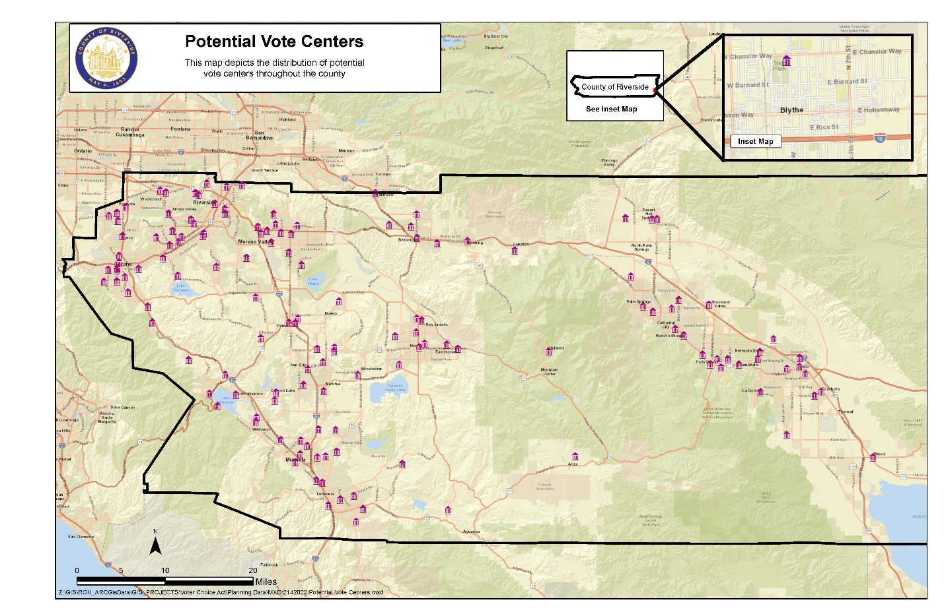Vote Center Minimum Requirements
Vote centers will be decided based on requirements established in statute, accessibility to voters with disabilities and language needs, availability, and public feedback. The Registrar of Voters will use historical data, as well as voter and population data to pick the best locations for vote centers.
The Registrar of Voters leaned heavily on the use of government buildings during the pandemic during November 2020’s implementation of a “VCA like” voting model. This methodology continued during the September 2021 election. These sites fulfill many of the considerations and criteria that the Voter’s Choice Act mandates that counties consider, which means that Riverside County voters will enjoy continuity in knowing where in-person options for voting are located. Additionally, the Registrar of Voters office plans to continue to maintain an active database of potential vote center locations that are surveyed on an ongoing basis to ensure they meet the accessibility needs of all voters. The county is working with communities to address any concern for locations and is actively working to incorporate resolutions to mitigate these concerns.
Vote Center Facility Recruitment Process
Past polling places from previous elections are reviewed and assessed to see if they meet Riverside County’s minimum requirements for a Vote Center. Locations that will not be able to accommodate Vote Centers due to square footage limitations, available timing or other factors related to specific requirements have been contacted to inform them that they will no longer be able to meet the more-stringent needs and standards set by the VCA.
The Registrar of Voters plans to send letters inquiring about the availability of potential sites for the June 2022 election in February 2022. This advanced communication is intended to help the department retain continuity with agency partners and help them plan for being available for multiple days of voting.
In addition to considering required criteria, a vote center survey assessment considers many of the other site selection elements that, while not required by law, impact the vote center siting process. Some examples of these site selection elements include path of travel, size of the voting room, the presence of adequate lighting (both inside and outside), the geographic area of the proposed site, internet connectivity, and electrical capacity.
Vote Center Layout
Elections Code §4005(a)(10)(I)(vi)(XI)
The voting experience at a Riverside County Vote Center is similar to voting at a traditional polling place, with some key exceptions. All Vote Centers offer multiple electronic check-in stations where elections staff are able to verify a voter’s identity easily and provide them quick access to their unique ballot.
Citizens can do the following at any of these in-person voting locations:
- Vote their specific in-person ballot on a ballot-marking device
- Cast a ballot in multiple languages
- Drop off their completed and signed Vote-by-Mail ballot envelope
- Register and vote on the spot utilizing Conditional Voter Registration
Each Vote Center features 10 ballot-marking devices and five check-in stations in an effort to promote a balance between timely customer service and the space and privacy for voters to freely cast their ballots. Vote Centers also include dedicated Personal Protective Equipment, or PPE, stations with hand sanitizer, sanitary wipes, face masks, shields and gloves to promote a healthy, inviting space and positive voting experience.
Vote Center Staffing
Elections Code §4005(a)(10)(I)(vi)(IX)
Riverside County is committed to giving voters the best voting experience possible. And that commitment starts with how we train our Election Officers. The Registrar of Voters hires two temporary employees as co-leads for each in-person voting site a month before the election and has them go through a rigorous Election Academy in preparation for the task at hand.
As Riverside County transitions to the parameters set forth of the Voter’s Choice Act, the additional week of in-person voting provides an opportunity for these leads to gain first-hand experience at the 26 centers open 11 days before Election Day. This will help them gain valuable experience before taking on the leadership role at the other sites throughout Riverside County.
Based on previous elections under the “VCA like” model and estimated needs for leads at each site, it is anticipated that 6 Election Officers will be at each site during the first week of in-person voting and 10 Election Officers will be at each site starting the weekend before Election Day.
Volunteers from the community also play a critical role in ensuring the success of Vote Centers. To that end, the co-leads at each of the Vote Centers will be joined by at least 8 volunteers starting on the weekend before Election Day. These volunteers will be well-prepared to help their fellow community members vote, as each one must go through a minimum of two hours training from Registrar of Voters instructors. These trainings are primarily conducted using the Zoom telecommuting platform, though some in-person training is available.
A critical component of the training process is to include information to ensure accessibility for voters with disabilities. Vote Center staff are trained to properly use the ballot marking device including the audio ballot.
Ballot Drop Box Formula and Considerations
Elections Code §4005(a)(10)(I)(vi)(II)
The Voter’s Choice Act requires counties to provide at least one ballot drop box location for every 15,000 registered voters. Riverside County looks at the voter population in each city and unincorporated areas in Supervisorial Districts to determine the number of ballot drop boxes. The Registrar of Voters will have approximately 87 ballot drop off locations for the June 2022 Election.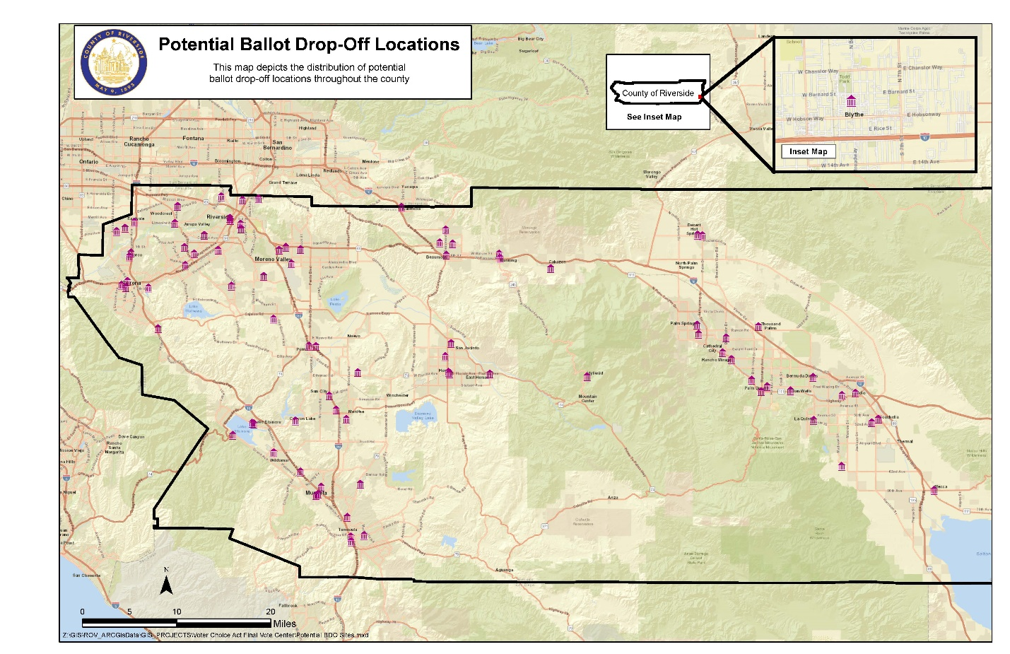The County of Riverside currently utilizes staffed ballot drop off locations, through a mix of boxes at all 28 City Halls in the county along with staffed drop-off boxes at select locations throughout the county. Like Vote Centers, these locations are selected based on their proximity to major transportation routes, with an emphasis on utilizing government buildings or well-established community gathering places such as community centers, libraries or churches.
Ballot Drop Box Minimum Requirements
Elections Code §4005(a)(10)(I)(vi)(VI)
In addition to the minimum requirements set forth in the Voter’s Choice Act, the California Secretary of State’s office provides additional regulations such as accessibility and language requirements. Riverside County meets the guidelines through conducting site assessments to ensure teams are positioned at each site in a spot that is conducive to all voters being able to drop off their VBM ballot. The county also displays a poster on each of its drop off boxes that tells the public the drop off is an official ballot box and provides instruction in all required languages.
Site Selection Suggestion Form on Website
Another way Vote Center and Ballot Drop-Off Box locations are selected for assessment is public feedback received through the county website at voteinfo.net/votecenter. The public can click on the Site Suggestion Form link and write a facility name, address and reason for suggesting the site on the fillable PDF document. The Registrar of Voters continually follows up on this valuable feedback and pursuing potential sites.

Services for Voters with Disabilities
Elections Code §4005(a)(10)(I)(vi)(X)
The County of Riverside is committed to supporting all voters, including those with disabilities, through the final transition to Vote Centers. The Registrar of Voters is well-prepared to make this final step through building on its successes in implementing the “VCA-like” model during the November 2020 and September 2021 countywide elections. In the spirit of continuous improvement to benefit county voters, the Registrar of Voters plans to expand and update services for voters with disabilities such as using an updated comprehensive accessibility survey, implementing a new training program to standardize surveying techniques and extending the ability to cast a ballot independently from home.
Updated Accessibility Survey and Training
Elections Code §4005(a)(4)(C)
In order to comply with additional accessibility requirements, the Registrar of Voters has reviewed the SOS Accessibility Checklist and created comprehensive surveys. Information from thorough surveys of each location is used to create draft facility layouts for each site to assist Vote Center leads in setting up equipment. The Registrar of Voters has also taken a more proactive approach to making sure that surveying staff works closely with those who lead the Vote Center trainings to ensure that co-leads at each site take mitigation into account when setting up a particular location.
Additionally, the Registrar of Voters has created an E-Learning Module focused on giving all staff members who conduct surveys a thorough, visual-centric learning experience that allows them to better grasp all the concepts of accessibility surveying and mitigation for items such as path of travel, accessible parking spaces, slopes and door pressure and other items needed to successfully complete the SOS checklist. This training ensures consistency with the terminology and methods taught to each staff member.

References for Services for Voters with Disabilities in Voter Guides
Elections Code §4005(a)(8)(B)(i)(IV)
The Voter Information Guide created by the Registrar of Voters for every election includes information on how voters with disabilities can request assistance, Disability Rights California’s Voting Hotline phone number, information about Remote Accessible Vote-by-Mail, or RAVBM and ways to contact the office for any general questions. Additionally, the guide specifies that voters unable to mark a ballot have ways to get assistance.
Requesting a Replacement Ballot or RAVBM
Elections Code §4005(a)(8)(B)(i)(IV)
Voters with disabilities may request a Vote-by-Mail ballot, replacement ballot or the RAVBM via the Registrar of Voters website at www.voteinfo.net, emailing us at ROVWeb@rivco.org, over the phone, in written form or in person at our office, located at 2720 Gateway Drive in Riverside. Additionally, voters will be able to make the request for a Vote-by-Mail or replacement ballot in person at any Vote Center.
Remote Accessible Vote-by-Mail
Elections Code §4005(a)(8)(B)(i)(IV)
Riverside County registered voters may request a downloadable ballot by connecting to the Remote Accessible Vote-by-Mail, or RAVBM, system. Riverside County partners with Democracy Live to provide this service. RAVBM provides voters the ability to request an electronic ballot. This electronic ballot can be downloaded to the voter’s computer, marked using their own assistive technology and then printed. This ballot can then be returned in the same manner as any VBM ballot, including any mailbox, Ballot Drop-Off Box location or Vote Center.
RAVBM was originally a voting option reserved for military and overseas voters and voters with disabilities, but is now available to all voters. RAVBM is accessible for voters who use assistive technology on their home computers, such as screen reader programs.
Accessible Voting Machines
Elections Codes §4005(a)(2)(B), §4005(a)(4)(D), §4005(a)(10)(I)(vi)(X)
All Riverside County Vote Centers will exclusively feature at least 10 accessible ballot-marking devices and will be flexible enough to expand that number depending on voter needs and the size of the voting room.
Voters will be able to mark their ballot using the touch screen display, the device’s Audio Tactile Interface or their own assistive technology. The Vote Center facility will be set up with the privacy of all voters in mind, which will provide voters with disabilities an autonomous voting experience. Voting stations will be arranged so that all voters are allowed the opportunity to cast their ballot privately and independently.
Reasonable Modifications at Vote Centers
Elections Codes §4005(a)(6)(D), §4005(a)(10)(I)(vi)(X)
Riverside County’s Vote Centers are created with the needs of all voters in mind. All of the ballot-marking devices at Vote Centers utilize a variety of audio and sensory accommodations to meet the needs of those needing assistance. These include screen reading, magnification and inverted colors, along with the capacity for a person to use their own devices used in everyday life to cast their ballot. Magnifiers are available upon request and chairs will be available at check-in tables and voting units upon request. If a voter needs additional assistance, Election Officers will be available to assist a voter as a visual guide.
Each Vote Center site is rigorously surveyed for accessibility, as this switch to the Voter’s Choice Act model allows the Registrar of Voters to pick the sites that are the “cream of the crop” in each city and unincorporated area of the county. The Registrar of Voter’s Operations team makes sure to provide threshold ramps if there are any slopes that can cause impediments to voters, cones to identify potential hazards and mats to cover tripping hazards. They also identify the ideal way for Election Officers to set up a site to ensure the most appropriate path of travel for all voters to have their best voting experience.
Curbside Voting
The Registrar of Voters is proud to be able to offer voters the ability to cast their ballot without having to leave their vehicle. Voters are able to partake in the Curbside Voting program by calling the Registrar of Voters upon their arrival at the parking lot of a Vote Center. Staff will ask the voter if they wish to cast a ballot on a paper ballot or a ballot-marking device. Two Election Officers will bring out an accessible voting unit setup, including the printer and battery supply for the voter’s convenience.
Toll-Free Voter Phone Line
Elections Code §4005(a)(10)(I)(vii)
The public will be provided a toll-free voter phone line to direct voters to the accessibility features in order to ask questions and receive voting and election-related information. The toll-free phone number will be published on the Registrar of Voters website, public service announcements and provided in media outreach and direct voter contact information such as Vote-by-Mail ballot inserts and the Voter Information Guide.
Voters that are deaf, hard-of-hearing or speech-disabled may use the California Relay Service by calling 711 to use the telephone system via a text telephone or other device. California Relay Service supports the following modes of communication; TTY, VCO, 2LVCO, HCO, STS, VASTS, ASCII or Voice.
Video Conferencing
The Registrar of Voters will utilize Zoom or Teams to provide American Sign Language interpretation assistance at all Vote Centers.

Language Assistance Services
The Registrar of Voters strives to provide comprehensive and innovative language assistance services to voters in a county that has seen an increased need over the past decade. From having dedicated bilingual staff prepare culturally appropriate translations, partnerships with organizations throughout Riverside County who represent our broad diversity of languages, to participating in many events in each region of the county. The Registrar of Voters is committed to providing numerous opportunities for language communities to learn about this final transition to Vote Centers.
Translated Reference Ballots and Language Assistance Card
Elections Code §13400
Per California Elections Code §14201, the Registrar of Voters is required to provide translated reference ballots at targeted precincts and a card indicating that translated reference ballots in Korean, Tagalog, Chinese (Mandarin) and Vietnamese are available at target precincts.
The targeted precincts are identified through a thorough Language Analysis and the corresponding ballot types are translated by a contracted vendor per requirements under California Elections Code §13307. With the new voting model, Riverside County will provide voters the ability to see a translated reference ballot at a Vote Center using one of the laptops and printers at each site. Each site has live connectivity which allows access to these files via a shared drive. Additionally, voters can request a translated reference ballot by telephone, mail or fax up to 10 days before Election Day.
Riverside County provides an inclusive language assistance card, which lists the availability of translated reference ballots and all language services available to Vote Centers.

Language Assistance Services included in voter guides and website
Elections Code §4005(a)(10)(I)(vi)(IX)
Voters will be notified several times throughout an election about their ability to request translated materials. The Voter Information Guide, which is mailed to all registered voters, as well as instructions inserted in each Vote-by-Mail package, includes information about what materials in different languages and language assistance services are available.
The Registrar of Voters also provides a complete list of language assistance services available under the new voting model on its website, www.voteinfo.net.
Bilingual Support Staffing and Supported Languages
Elections Code §4005(a)(10)(I)(vi)(IX)
The Registrar of Voters makes sure that all Vote Center locations are properly staffed to meet the language needs of all voters, including making sure that each site has multiple Spanish speakers serving as Election Officers. The office goes further by determining which Vote Centers are located in precincts that meet language requirements under the federal Voting Rights Act for in-person language assistance. Additionally, the Registrar of Voters plans to seek public input regarding which Vote Centers should have staff members who are fluent in specific languages.
At Vote Centers identified as meeting language assistance requirements, voters will still have alternate options to receive in-language assistance including translated written materials, assistance with Registrar of Voters staff via telephone call or assistance through video conferencing.
Toll-Free Voter Phone Line and Multilingual Public Call Center
Elections Codes §4005(a)(10)(I)(vii), §4005(a)(10)(I)(i)(I)
Leading up to Election Day, the Registrar of Voters operates a public call center to assist voters that is staffed with bilingual operators in federal and state required languages before, during and after an election to provide in-language assistance. Language voters may also call a toll-free voter phone line to ask questions and receive voting and election-related information. The toll-free phone number is 1(800) 773-VOTE (8683) and it is activated. The number can be found prominently on the Registrar of Voters Website, www.voteinfo.net, public service announcements, departmental news releases and direct voter contact items such as the Voter Information Guide. This will be the lone toll-free number to serve the public.
Video Conferencing
In addition to the in-person support provided to voters at Vote Centers, the Registrar of Voters also plans to use video teleconference platforms to provide direct one-on-one multilingual assistance to voters. This ensures that voters needing language assistance will be able to interact with trained bilingual staff who can verbally and visually guide the voter to meaningfully participate in the process, even if there is not a particular bilingual staff member at the Vote Center. Telephone support will also be available depending on the preference of the requesting voter.
Supported languages include:
- Spanish
- Vietnamese
- Chinese (Mandarin)
- Chinese (Cantonese)
- Korean
- Tagalog
- American Sign Language

Voting Technology
Direct Connection to Voter Database
Riverside County’s formal adoption of the Voter’s Choice Act allows the Registrar of Voters to fully take advantage of a mechanism that allows for the efficient and secure processing of eligible voters at any Vote Center location throughout the county. Instead of the former system which called for the creation of paper rosters of voters assigned to a particular polling place, this new voting method allows for a direct connection to the Registrar of Voters election management system.
The Registrar of Voters utilizes five laptops located at the check-in station of each Vote Center. A voter completes a ballot request, where they indicate that they have not voted their original ballot which was sent in the mail and that they are surrendering the use of that ballot in order to vote in-person. Election Officers are able to use that signed document, or a signature placed on a roster page at the check-in table, to search for the voter in the election management system. Once the Election Officer finds the voter in the database, they are given an indication as to whether the voter has already voted or is eligible to cast a ballot.
Voting System
Riverside County replaced its voting system in 2019 due to the state’s decertification of certain types of voting equipment which restricted the amount of allowable modifications in a highly-regulated environment. In short, there are few options in California.
The Registrar of Voters entered into a contract with Dominion Voting as a voting system solution for its ballot-marking and tabulation equipment. The Registrar of Voters utilizes their Democracy Suite voting equipment. Each Vote Center features 10 of their ballot-marking devices, which is used exclusively for all voters.
In order to fully maximize the voter experience, the Registrar of Voters also plans to utilize the company’s Ballot On-Demand technology to provide a paper ballot for those voters who prefer that option. The office is also exploring adding technology that scans each voter’s ballot at the vote center as they cast it.
New Technology
In addition to improving the voter experience, the Registrar of Voters will be unveiling some new technological advances with the move to Vote Centers that will improve cost efficiencies and help reduce the amount of time it takes for Election Night results to be tabulated.
Ballot On-Demand
Under the previous voting method, Riverside County relied on a paper ballot inventory for all voters who were assigned to vote at their neighborhood polling location. This meant that each location had a certain number of voting precincts based on the different ballot types. Riverside County generally has over 300 ballot types in a large election. Because the Voter’s Choice Act model gives voters the ability to vote at any vote center, utilizing a paper ballot inventory system would be extremely ineffective and a waste of taxpayer money.
The Registrar of Voters successfully ensured voters cast the correct ballots while voting in person in November 2020 and September 2021 by utilizing its inventory of Accessible Voting Units, or AVUs. The vast majority of voters prefer using this ballot-marking device, though a small number of voters still insisted on wanting a “paper ballot.”
Starting with the June 2022 Gubernatorial Primary Election, the Registrar of Voters plans to have special printing technology available at each Vote Center where Election Officers can print each voter their specific ballot type. This “Ballot On-Demand” system ensures that the Registrar of Voters does not have to create a larger-than-necessary paper ballot inventory.

Precinct Scanners
Under the previous voting method, Riverside County voters would place their completed paper ballots in a blue ballot box before leaving the in-person voting location. All the ballots were then securely removed from the blue ballot box once polls were closed and they were securely transported to the Registrar of Voters office to be counted.
The Registrar of Voters plans to add new Precinct Scanner machines at each Vote Center which records all votes cast on each ballot as they are deposited into the ballot box by the voter. All of the results are saved on the machine on a memory card, which will be securely transported to the Registrar of Voters office after polls are closed. This system, along with having the paper ballots as a fail safe in case there are any issues with the memory cards, ensures that election results can be processed in a more efficient and timely manner.

Voting Security
The Registrar of Voters works closely with the county’s Information Technology department to pursue security measures to protect ballot integrity, voting equipment, voter registration systems and ensure the eligibility of voters. Although threats are constantly changing and incidents are unique, Riverside County remains steadfast in implementing best practices to prepare for threats and incidents. The Registrar of Voters continues to improve current systems and actively implement new procedures, while instructing all temporary and permanent employees to be vigilant in keeping an eye on potential threats. These warnings are supported with thorough training and the implementation of physical and cybersecurity controls. The county also has inherent security measures in places on its network to ensure systems are not compromised.
Security and Contingency Plans to Ensure Prevention of Disruption
Elections Code §4005(a)(10)(I)(vi)(VIII)(ia)
The Registrar of Voters has a multi-pronged approach to ensure prevention of disruption to election operations through partnerships, internal controls and procedures.
State, Federal, Local Partnerships
Our office has strong working relationships with Riverside County’s Chief Information Security office, as well as direct connections with the Department of Homeland Security, Federal Bureau of Investigation and the Election Assistance Commission.
There is increased collaboration around election cycles before and after the election, which includes enhanced security awareness, communication, regular correspondence and virtual meetings.

Internal Controls
The Registrar of Voters enforces a strong approach to ensure security both at its physical location and virtually among all of its employees devices.
During election cycles, the Registrar of Voters restricts access to its main floor not only to the general public but temporary employees as well. The building is also watched 24 hours a day during this time by a private security company.
Mobile device management allows total control of securing and enforcing policies to smartphones, tablets and other devices. It allows for the ability to remotely wipe a device, use password enforcement, enabling application whitelisting or blacklisting, use data encryption enforcement, control software updates, mandate password changes and more.
Leads at every Vote Center have a smartphone to notify them in the event of an emergency. Additionally, these individuals receive training during the Election Academy on how to handle election-specific emergency situations. Each Voter Center has five Uninterrupted Power Supply, or UPS, units to keep the ballot-marking devices operational in case of a loss of power.
Procedures, Methods and Standards
Chain of custody procedures are used as an administrative control as part of the overall strategy to secure election operations. These procedures ensure that physical tracking of voting system equipment is in place.
Voting system components are secured in rooms that require badge access for entry and include surveillance cameras. All voting equipment that is deployed off-site for elections is numerically sealed and tracked until returned to the Registrar of Voters office.
Third-party companies who deliver voting equipment to sites sign chain of custody documents and delivery receipts, while election personnel verify seal logs for voting equipment at in-person voting locations. The personnel also periodically check security seals throughout the day and report any broken seals or suspicious activity. Registrar of Voters representatives sign for the voting equipment upon its return and then it is inventoried and placed in a secured location.
Security and Contingency Plans to Ensure Continuation of Election in Event of Disruption
Elections Code §4005(a)(10)(I)(vi)(VIII)(ib)
The Registrar of Voters prepares to prevent disruptions during in-person voting; however, it is equally important to be prepared to respond to the real possibility of an incident or disruption. This section outlines the steps taken to be prepared to continue elections operations in the event of a disruption.
Vote Center Response During the Voting Period
During the voting period, election support personnel are located strategically at sites throughout Riverside County, ready to respond to any incident. These satellite depots include replacement ballot-marking devices, key documents and supplies and are trained to handle technical issues. The goal is that these teams can respond to situations in less than half hour. Vote Center leads also have emergency contact information for key Registrar of Voters and County IT personnel and a dedicated helpdesk that can quickly resolve issue and/or dispatch support teams in the field.
All ballot-marking devices function independently and operate without any connectivity to the Internet. In the event of a power outage, there is one UPS for every two voting units to ensure no lapse in voting. And while the Registrar of Voters utilizes Wi-Fi connectivity to access its Election Management System at Vote Centers to update voter history in real-time, the Registrar of Voters has voters sign paper roster and can implement Provisional Ballots to allow for accurate voter participation in the event of disruption.

Fiscal Impact
Because Riverside County replaced its voting equipment in 2019 and because of the Registrar of Voters using the “VCA-like” model for the past two elections, there is some data showing how much it costs to conduct a countywide election using the Voter’s Choice Act model compared to the Polling Place model.
 | Nov 2016  General | June 2018  Primary | Nov 2018  General | Mar 2020  Primary | Nov 2020  General | Sept 2021 Recall
Labor | $3,019,209 | $2,522,527 | $2,987,737 | $3,490,851 | $4,338,809 | $4,501,483
Printing | $1,636,387 | $1,764,759 | $1,787,320 | $1,577,173 | $2,451,638 | $2,171,384
Postage | $354,475 | $346,783 | $358,043 | $631,528 | $685,985 | $777,980
Equipment | N/A | N/A | N/A | N/A | $430,497 | $337,351
Total | $5,010,071 | $4,634,069 | $5,133,100 | $5,699,552 | $7,906,929 | $7,799,198
Registered Voters | 1,022,375 | 983,917 | 1,040,218 | 1,115,675 | 1,243,154 | 1,293,611
Turnout | 769,193 | 346,472 | 650,545 | 482,272 | 1,016,896 | 720,600
% Turnout | 75.24% | 35.21% | 62.54% | 43.23% | 81.80% | 55.70%

Overview of Voter Education and Outreach Plan
The California Voter’s Choice Act, or VCA, requires the County to develop a Voter Education and Outreach Plan that provides transparency and informs voters on all aspects of the new voting method. This includes the services and information available at the Vote Centers and Ballot Drop-Off Box locations, as well as information specific to voters with disabilities and language minority voters.
Public meetings will be held with a wide variety of community organizations and individuals that advocate on behalf of, or provide services to, the disability and language minority communities. The Registrar of Voters plans to hold public consultation meetings, public hearings and host educational workshops in an effort to give the public an opportunity to provide input and feedback directly on Riverside’s education and outreach plan and to ensure that all residents have a firm understanding about how future voting will be conducted in Riverside County.
Additionally, the Registrar of Voters plans to participate in a wide variety of community events and develop innovative ways to communicate with voters using the ways they consume information. This plan highlights the outreach events this office will coordinate and attend, outlines the new messaging strategies that will increase our community presence and details how resources will be allocated.
The Registrar of Voters is committed to cultivating new relationships with community organizations, interested stakeholders and individual voters, as well as strengthening existing relationships with community partners during this transition to the Voter’s Choice Act.
Summary of Goals
- New Riverside County Registrar of Voters website
- Hiring a Senior Public Information Specialist
- Public Hearings that thoroughly explain the Voters Choice Act
- Gateway to Vote Center virtual workshops
- Attending community engagement events
- Partnerships with colleges and universities
- Partnerships with high schools
- Multiple direct voter contacts
- Staff-created voter education videos
- Increased social media presence
Public Hearings
The Registrar of Voters plans to have the following public hearings as part of its compliance with the Voters Choice Act.
Date | Time | Location | Details
March 9, 2022 | 6:00 pm | Zoom | Accessibility Needs Public Consultation
March 16, 2022 | 6:00 pm | Zoom | Language Needs Public Consultation
April 6, 2022 | 6:00 pm | Zoom | Draft Election Administration Plan Public Hearing
May 24, 2022 | 6:00 pm | Zoom | General Voter Education Workshop
May 25, 2022 | 6:00 pm | Zoom | Accessibility Voter Education Workshop
May 26, 2022 | 6:00 pm | Zoom | Spanish Voter Education Workshop
May 27, 2022 | 6:00 pm | Zoom | Tagalog Voter Education Workshop
May 31, 2022 | 6:00 pm | Zoom | Mandarin Voter Education Workshop
June 1, 2022 | 6:00 pm | Zoom | Cantonese Voter Education Workshop
June 2, 2022 | 6:00 pm | Zoom | Vietnamese Voter Education Workshop
June 3, 2022 | 6:00 pm | Zoom | Korean Voter Education Workshop

2022 Messaging
Based on community feedback and input, the Registrar of Voters has established the following messaging points for the June 7, 2022 Gubernatorial Primary Election that will be prevalent in all outreach and education materials.
- All voters will receive a Vote-by-Mail ballot
- Riverside County voters can vote in-person at any Vote Center
- The many ways voters have to easily cast their ballot
- Checking voter registration status to be “Voting Ready”
Community Partners
Successfully maintaining a community outreach program includes maintaining established partnerships with community-based groups and organizations throughout the county. The Registrar of Voters makes it a point to meet and communicate with dedicated individuals from various organizations across the county including advocacy groups, civic groups, chambers of commerce, youth groups, churches, political organizations and other individuals. A full list of community partners is included in the appendices section.
Voting Accessibility Advisory Committee (VAAC)
Created in 2015, the mission of the VAAC is to provide a forum where the community, particularly those who are elderly or those with disabilities, can advise and assist, voice concerns and provide recommendations to the Registrar of Voters. One outcome sought through these meetings is to find opportunities to ensure all in-person voting locations are equally accessible to all voters. Committee members provide expertise on situation accessibility needs, suggestions for potential procedural additions or changes and positive feedback on addressing accessibility standards and reaching out to voters with accessibility needs. These meetings are held quarterly and are open to the public.
Language Accessibility Advisory Committee (LAAC)
Created in 2013 originally as the Registrar of Voters’ Community Outreach Group, the LAAC was expanded to its current form in early 2018. This citizen group was originally tasked with addressing accessibility in the Spanish language at polling places, but has grown to provide language access in all aspects of the operation, specifically assisting not only Spanish-speaking citizens, but also the needs of Riverside County’s Korean, Chinese (Mandarin and Cantonese), Tagalog and Vietnamese speaking residents. The mission of the LAAC is to work with partners to ensure activities, program and policies are providing equal access to the ballot and relevant voting information. These meetings are held quarterly and are open to the public.
Voter Education Workshops for Language Communities
The Registrar of Voters will host multiple voter education workshops to provide information about Vote Centers and Ballot Drop-Off Locations for each of Riverside County’s federal and state required languages. In 2022, these languages include Spanish, Vietnamese, Chinese (Mandarin and Cantonese), Korean and Tagalog.
Each workshop will include information about the new voting model, language assistance services, ballot drop-off options and a how-to on items such as requesting translated election materials and voting equipment overview. Workshop information will be announced at least 10 days in advance of meeting dates and shared with local language partners to encourage citizen participation.
Methods to Identify Language Communities
The first tool that will be utilized is the county’s Language Analysis process to determine which voting precincts have a certain threshold of voters who speak a language other than English and require translated ballots. Voters may also notify the Registrar of Voters if they have a language preference or request language assistance through voter registration forms. This data, along with the United States Census Bureau can help identify communities that have limited-English proficiency and language needs.
Community partners also actively provide the Registrar of Voters with input on where there are large swaths of language communities in Riverside County. The Registrar of Voters will team up with its community partners to determine the best number of workshops, workshop dates, preferred format for meetings and locations and what materials to distribute to best serve this voting community. The workshops will be announced at least 10 days in advance.
Remote Accessible Vote-by-Mail Outreach
The Registrar of Voters is developing a plan to inform voters about the availability and functionality of Remote Accessible Vote-by-Mail (RAVBM). Different strategies will be created based on the target audience and best practice on how to reach them. This program, which started in 2018, will be included in the department’s overall media strategy to inform and engage voters leading up to the June 7, 2022 Gubernatorial Primary Election.
High Schools
The Registrar of Voters is committed to fostering lifelong voters through actively working with Riverside County high schools to support their civics and government programs. The department provides voter registration cards and other support as an active participant in the Secretary of State’s High School Voter Education Weeks program in September and April. The Registrar of Voters also encourages all eligible high school students to participate as poll workers on Election Day.
Colleges and Universities
The Registrar of Voters has its Registration, Outreach, Voting and Educational Resource, or ROVER, mobile community engagement unit and plans to update its look and use it as a resource to draw the attention of students, faculty, and staff.
Initial conversations have taken place to develop comprehensive marketing plans for colleges and universities and explore the possibility of hosting either a vote center or ballot drop-off box on campus. The Registrar of Voters has already used the University of California at Riverside and Moreno Valley College as in-person voting locations and ballot drop-off sites in recent years and planning efforts have already begun to have them continue as Vote Centers and/or Ballot Drop-Off Locations. The Registrar of Voters hopes to bring this opportunity to other potential college partners.
Business Partners
The Registrar of Voters plans to partner with business associations and chambers of commerce to provide speaking engagements, voter registration training and informational tabling at meetings. The Registrar of Voters is planning a “Welcome to Vote Centers” video information series.

Speaking Engagements and Community Events
Virtual Speaking Engagements
The speaking engagement component of Riverside County Registrar of Voters community outreach program is an integral part of outreaching to voters of many different backgrounds throughout Riverside County. Covering a diverse and expansive area, the program aims to achieve the following goals:
- Educate voters on the electoral process, including the evolution of Riverside’s in-person voting to Vote Centers
- Provide information on special programs, online features and voter registration
- Network and pursue collaborative opportunities
The focus is to provide small and large-scale communication to the community. Virtual speaking engagements include attending various community meetings and events and conducting non-partisan, neutral and culturally sensitive presentations.
As many groups exist within Riverside County, virtual speaking engagements allow the Registrar of Voters to promote services, build partnerships and interact with various communities. Targeted groups include the following
- Community groups
- Rotary Clubs
- Parent Teacher Associations
- Cultural Clubs
- Service organizations
- Faith-based organizations
- Churches
- Universities/Colleges
- Community Colleges
- Student organizations
- Non-profit organizations
- Senior citizen centers
- Citizenship classes
- Professional associations
- Public service agencies
- Workforce development agencies
- Youth groups

Practice Makes Perfect
Sometimes voting equipment can be intimidating for voters. That’s why the Registrar of Voters team will host “Practice Makes Perfect” voting equipment demonstrations throughout Riverside County in 2022 so that voters can become more comfortable using the ballot-marking device, including navigating the screen when there are many candidates, using the Audio Tactile Interface and trying out the new Precinct Scanners.
Community Events
To maintain a strong presence in the community, the Registrar of Voters plans to focus its community outreach attendance to both small-to-medium and large-scale events. The Registrar of Voters will be present at these events to provide information about the transition to the vote center model, voting options and other election information. Staff will interact and engage with the public, answer questions, facilitate demonstration of the ballot-marking devices used at Vote Centers and assist with filling out voter registration forms. Participating in these events provides the Registrar of Voters potential access to thousands of individuals throughout the county.
Elected Officials and Government Agencies
The Registrar of Voters will leverage existing working relationships with government agencies and elected officials to raise public awareness of the transition to vote centers. This partnership includes reaching out to all City Clerks to share information about the new voting method.

Community Engagement Suite
General Media Plan
Elections Code §4005(a)(10)(I)(i)(I)
To inform Riverside County voters that the experience they had casting their ballot during the past two elections is now permanent, the Registrar of Voters plans to reach as many voters as possible. By using a blend of social media, direct mail, print, broadcast, radio, staff-created informational videos and press releases and availability to generate news coverage, the department aims to saturate all consumable media platforms with information to create a more informed and engaged electorate.
Media Partners
Elections Codes §4005(a)(10)(I)(i)(II), §4005(a)(10)(I)i)(VIII)
The Registrar of Voters will provide press releases, infographics, video content and social media content for mass distribution and publication to existing media partners and seek out other trusted media sources to help communicate messages to Riverside County voters about relevant changes to their voter experience. This includes accessibility options, how to request an accessible ballot, information about Vote Centers and Ballot Drop-Off Box Locations, key election dates and other election-specific news.
Additionally, Registrar of Voters Rebecca Spencer and Assistant Registrar of Voters Art Tinoco often appear on local media to speak as elections experts and give context to voters about what is happening when they cast their ballot.
Language Media Partners
Elections Code §4005(a)(10)(I)(i)(I)
Riverside County continues to see its communities become more diverse, which is reflected in the amount of language media outlets there are in the county. The Registrar of Voters has dedicated full-time staff members who serve as liaisons to larger language communities and brings on temporary staff members to meet that need in other language communities. The Registrar of Voters continues to actively work with all local language media partners. Information about the 2022 elections, the office’s toll-free voter assistance hotline and increased options at Vote Centers to get language assistance will be shared with language media partners.
Direct Voter Contacts
Elections Code §4005(a)(10)(I)(i)(X)
The Registrar of Voters plans to send two direct mailers, along with the County’s Voter Information Guide in late April and a Vote-by-Mail ballot package in May to advise all registered voters about the upcoming election. There will be some mention that the way voters have become accustomed to voting since the start of the COVID-19 global pandemic is now the voting method Riverside County will use going forward. The mailers will be designed to catch the voter’s attention by using messaging geared toward the convenience of Vote Centers and voting by mail. Mailers will also provide information about when to expect election-specific items in the mail and other tips to assist voters.
Postage-Paid Postcard for Requesting Materials
Elections Code §4005(a)(8)(B)(iii)
All Riverside County registered voters will receive a postage-paid postcard in their Voter Information Guide to request election materials in alternate languages. Instructions for completing and returning the postcard will be included in the guide, as well as being featured on the Registrar of Voters website.
Public Service Announcements
Elections Codes §4005(a)(10)(I)(i)(VIII), §4005(a)(10)(I)(i)(IX)
There are a lot of opportunities to utilize traditional media outlets such as billboard advertisers, ads on bus stops and television commercial outlets who are willing to share government messages at little or no cost. The Registrar of Voters plans to aggressively seek out these opportunities to supplement paid advertisements.
Additionally, the Registrar of Voters plans to continue to build upon its portfolio of staff-created videos to inform and educate voters about how to mark and return their Vote-by-Mail envelope, how to use the ballot-marking devices and other tutorials.
Social Media
The Registrar of Voters will use social media to attract new voters who may not otherwise be familiar with voting and provide information to existing voters about the changes to Vote Centers as well as updates on critical deadlines, events, voting tips and where to find their nearest place to vote in person. One benefit of social media that Registrar of Voters staff looks to capitalize on is showing in real-time how many steps go into an election and the lengths staff goes through to ensure security.
Departmental Public Information Specialist
Because of the specific needs of the Registrar of Voters office to reach out to Riverside County voters in a short amount of time, the department plans to hire a Senior Public Information Specialist who can skillfully work with media and community partners to get the word out about the transition to the Voter’s Choice Act. This individual would also assist the department in increasing public outreach efforts in explaining the intricacies of conducting an election.
Website
Elections Code §4005(a)(10)(I)(i)(IV)
The Registrar of Voters plans to do a complete overhaul of its website presence in the next year or two. However, given the short timeframe between the implementation of the Voter’s Choice Act and the June 7, 2022 Gubernatorial Primary Election, the Registrar of Voters plans to add an informational page about Riverside County’s new voting method on its current website, www.voteinfo.net. This page will include the final version of this Election Administration Plan, methods to request an accessible Vote-by-Mail ballot and how to use it, lists of Vote Center and Ballot Drop-Off Box locations, and other Voters Choice Act information.

Projected Budget for Voter Outreach
The following table shows the advertising and voter outreach budgets for the 2020 and 2021 elections as well as the estimated budget for the June 2022 election.
Elections | Advertising | Postcards | Outreach Events and Education Materials
March 2020  Vote Center | $31,044 | N/A | Not Tracked
November 2020  Vote Center | $184,437 | N/A | Not Tracked
September 2021  Vote Center | $29,174.80 | N/A | Not Tracked
June 2022  Vote Center | $500,000 | $1,300,000 | $250,000

Election Activities & Support
Logic & Accuracy Testing
All equipment will start to be configured for the June 2022 Election in April 2022 after the certified list of candidates is received from the Secretary of State. In accordance with state law, testing will be conducted to ensure that each piece of equipment is programmed accurately and captures the correct voter selections and tabulates them correctly. This testing of machine logic and accuracy is conducted on all ballot tabulators at the Registrar of Voters office used for counting ballots and all precinct scanners, ballot printers and ballot-marking devices sent out for use at Vote Centers.
This testing process is open to the public. A public demonstration showing that the equipment has been properly tested for service will be conducted approximately three weeks before Election Day.
Elections Materials & Resources
County Voter Information Guide
The Registrar of Voters produces a comprehensive County Voter Information Guide before each election. This guide, which includes an English and Spanish version, is generally mailed to all voters about 40 days before Election Day. This guide’s primary function is that it includes a sample ballot for a voter’s specific ballot type in the upcoming election. This guide will also include detailed information on the Vote-by-Mail process, a full list of Vote Center and Ballot Drop-Off Box locations, candidate statements, measure material and options for requesting a replacement VBM ballot packet. The Guide is available in both large-print and online formats. It also contains a postage-paid application on the back cover in case the voter chooses to update their contact information or update their language preference.
An accessible County Voter Information Guide is available on the Registrar of Voter website, www.voteinfo.net, starting 29 days before Election Day.
The State’s Voter Information Guide is mailed separately by the Secretary of State’s office. That guide includes information on statewide candidates and propositions and can be accessed online by visiting the Secretary of State’s Elections page, www.sos.ca.gov/elections.
Vote-by-Mail Ballot Packet
Every registered voter in Riverside County will receive a Vote-by-Mail packet in the mail, which the Registrar of Voters office mails outs starting 29 days before Election Day. This packet includes the voter’s official ballot, a postage-paid return envelope, informational inserts and a voting instruction sheet that includes a peel off “I Voted” sticker. Election materials, like official ballots, are not forwarded by the US Postal Service, but rather they are returned to the Registrar of Voters for processing as undeliverable.
Voter Postcards
All registered voters will receive two postcards informing voters of the upcoming election and contact information. The first postcard will be mailed at the end of April and the second postcard will be mailed before the 11-day Vote Centers open.
Registrar of Voters Website
Beginning 29 days before Election Day, the Registrar of Voters website will be updated with the following information:
- Voter Look-Up Tool, which allows any Riverside County voter to
  - Verify their voter registration information
  - Verify their voted ballot has been received by Riverside County
  - Find the nearest Vote Center to their residence
  - Access their County Voter Information Guide and accessible ballot
- Interactive Web maps for Vote Centers and Ballot Drop-Off Box Locations, including hours of operation, special instructions and directions
- Election Results
- Information on accessible voting options, including information on what is available at a Vote Center, Curbside Voting, Remote Accessible Vote-by-Mail and materials in accessible formats.
Phone/Relay Options
Voters may call (951) 486-7200, or the California Relay Service at 711 to obtain election information including Vote Center and Ballot Drop-Off Box locations. Translation assistance is available for voters in many languages.

Post-Election Activities
Canvass – Vote-by-Mail
Starting 20 days before Election Day, the Registrar of Voters begins processing returned Vote-by-Mail ballots, which includes the extraction and review of the official ballot from the Vote-by-Mail envelope. Ballots returned up to Monday afternoon before Election Day are included in the initial election night results released shortly after 8:00 pm.
Each returned Vote-by-Mail ballot envelope is processed through a mail sorter which sorts the ballot by voting precinct. This process takes a picture of the envelope with the voter’s signature, which is uploaded into the department’s election management system. Staff then compares the scanned signature image to the signature on file in the voter’s registration or other supporting documentation. If a voter forgets to sign their return envelope or a signature does not match a voter file, a letter and form is sent to the voter to give them a chance to cure the discrepancy. Signatures that cannot be determined go through multiple levels of escalated review, with the Registrar of Voters making the final determination.
Once a signature is deemed valid, ballot envelopes are taken to the extraction room where, with the assistance of machines, staff extract the ballots from the identification envelopes. This ensures voter privacy and that all ballots are secret. After extraction, ballots are moved to the processing room where teams review the ballots for damage and prepare them for tabulation. Damaged ballots that will not run through the tabulators are reproduced by teams of two. They are logged in the quality control log with the original ballot.
After processing, ballot cards are then sent through the tabulators. Scanned images of ballots may be sent to adjudication where teams of two analyze the ballot images to determine voter intent by reviewing ambiguous marks, ovals not filled properly, mistakes and write-ins. All decisions made by the adjudication team are logged in the system and reviewed by a Supervisor.
After tabulation, the paper ballots are stored in precinct-specific boxes and move to a secure storage room under 24-hour surveillance cameras and may be reviewed at any time during the certification process. Any overflow boxes are stored in the secured on-site warehouse area near the ballot storage room. This area is securely caged and also monitored by video surveillance.
Canvass – Vote Centers
Each evening, the co-leads at each Vote Center location will return Vote-by-Mail ballot envelopes, all voted ballots, and all laptops and routers. Included with the voted ballots is a Ballot Statement that ensures chain-of-custody, any Conditional Voter Registration ballots and plastic envelopes that contain all spoiled ballots, surrendered Vote-by-Mail ballots and envelopes, and completed Voter Registration forms. No voter personal information or activation cards for the ballot-marking devices are left overnight at Vote Centers.
On Election Night, the Registrar of Voters will process all in-person ballots from the Vote Centers, including any ballots picked up from selected high-volume sites by Registrar of Voters teams during the day.
Conditional Voter Registration and provisional ballots cast at Vote Centers or the Registrar of Voters office are initially processed by confirming a voter’s eligibility. Once confirmed, the voter’s registration is updated and the ballot is extracted, processed and tabulated like all other ballots. These ballots are included in the final official results.
1 Percent Manual Tally
To ensure that the ballot scanners are tabulating correctly, the Registrar of Voters conducts a manual tally on 1 percent of all the voting precincts in Riverside County, including all Vote-by-Mail ballots and Vote Centers. Precincts are selected randomly the Thursday morning following Election Day by rolling dice. Additional precincts are later selected by the Registrar of Voters to ensure that all contests have been audited at least once. The public is encouraged to participate in the random selection and observe the process.

Appendices
Vote Center Layout
Each Vote Center will feature a similar layout, including a Sanitization Station with an assortment of PPE items, multiple check-in stations for voters to request to vote in person, 10 Accessible Voting Units for voters to securely make their selections and a scanner where voters will be able to cast their completed ballot.
Here is a diagram of the Ysmael Villegas Community Center in Riverside for the September 2021 Recall Election. This closely depicts what a typical Vote Center would look like.

Vote-by-Mail Posters
California Elections Code requires that all official county ballot drop-off locations have specific instructions to voters. Riverside County meets and exceeds these standards by affixing the below posters to each of its drop-off boxes. The posters include instructions in all of Riverside County’s mandated languages, including English, Spanish, Chinese (Mandarin), Korean, Tagalog and Vietnamese.
These posters are included on boxes at all City Clerk’s offices, boxes that are staffed with Registrar of Voters staff members and the permanent drop-off boxes outside the Registrar of Voters office that are open 24 hours a day during an election.

E-Module Learning for Surveys and Mitigation
The Registrar of Voters utilizes a new training module that was created internally by staff members to help create a more standardized approach to teaching newer employees on how to conduct site surveys and provide the proper mitigation to make all sites accessible.
Here are a couple of screenshots of this module.
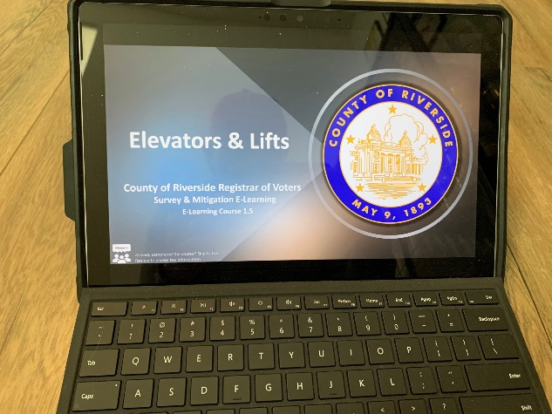

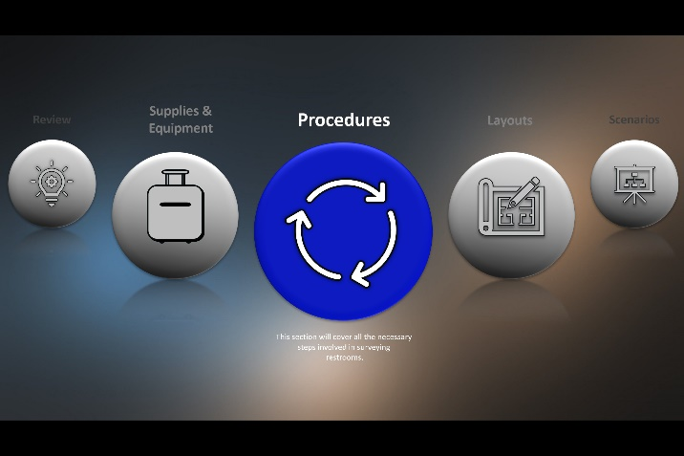

Voting Accessibility Advisory Committee Meetings
Attached is a recent agenda and invitation letter for the Registrar of Voters’ long-standing Voting Accessibility Advisory Committee. Meetings are open to the public and held on a quarterly basis.

Language Accessibility Advisory Committee Meetings
Attached is a recent agenda and invitation letter for the Registrar of Voters’ long-standing Language Accessibility Advisory Committee. Meetings are open to the public and held on a quarterly basis.

Community Partners
If you or your organization would like to partner with the Riverside County Registrar of Voters on Vote Center outreach and education, please visit the website www.voteinfo.net/votecenter or email ROVWeb@rivco.org.
Language Community Partners
- Asian-Americans Advancing Justice – Los Angeles
- Hispanic Women Network
- LULAC
Disability Community Partners
- Blindness Support Services
- Disability Rights California
- Community Access Center
Political, Advocacy and Professional Organizations
- Common Cause
- American Civil Liberties Union
- League of Women Voters
- National American Association of Colored People
- Riverside County Political Party Central Committees

Vote Center and Ballot Drop-Off Box Locations for 2022
The following pages contain a list of proposed vote center and ballot drop-off locations for the June 2022 Primary Election.

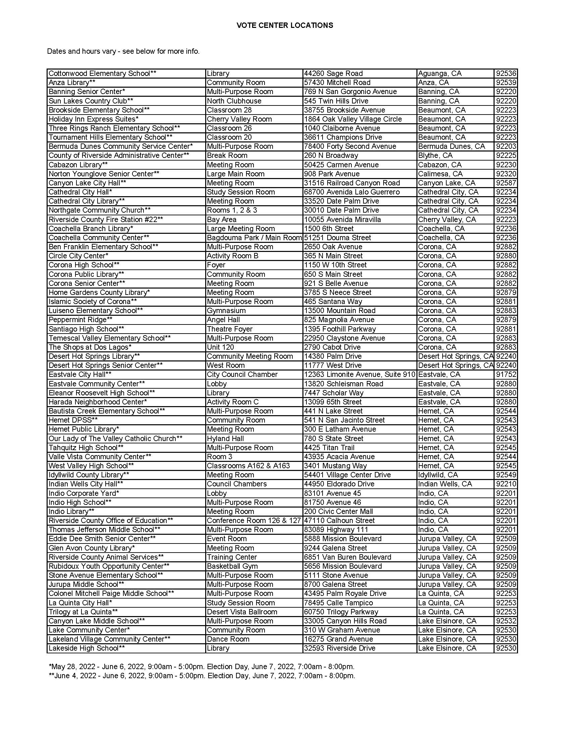

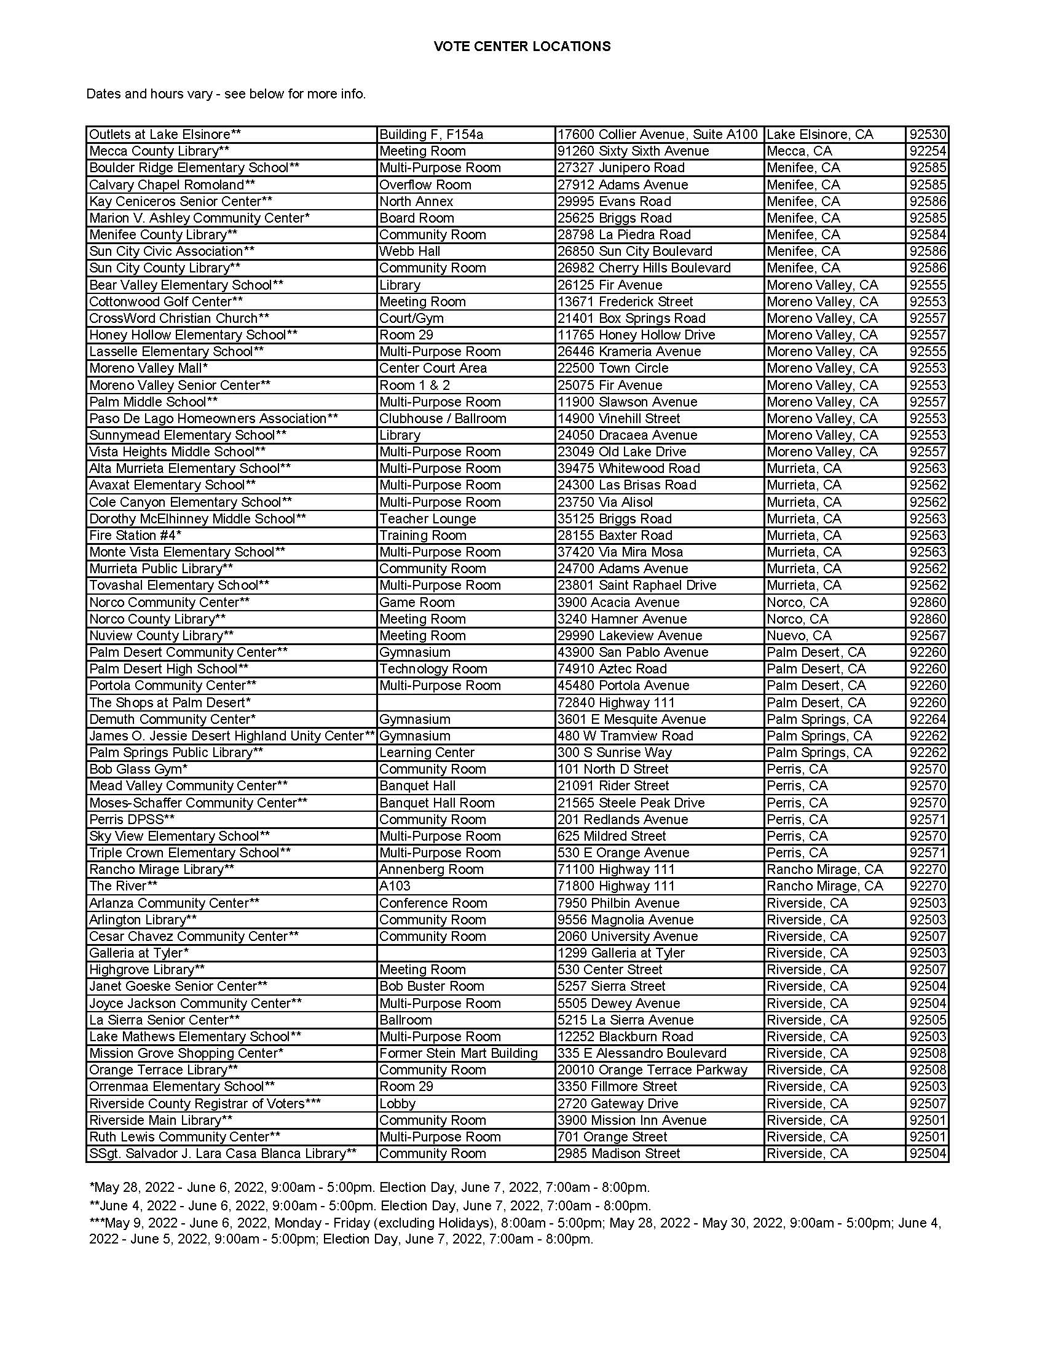

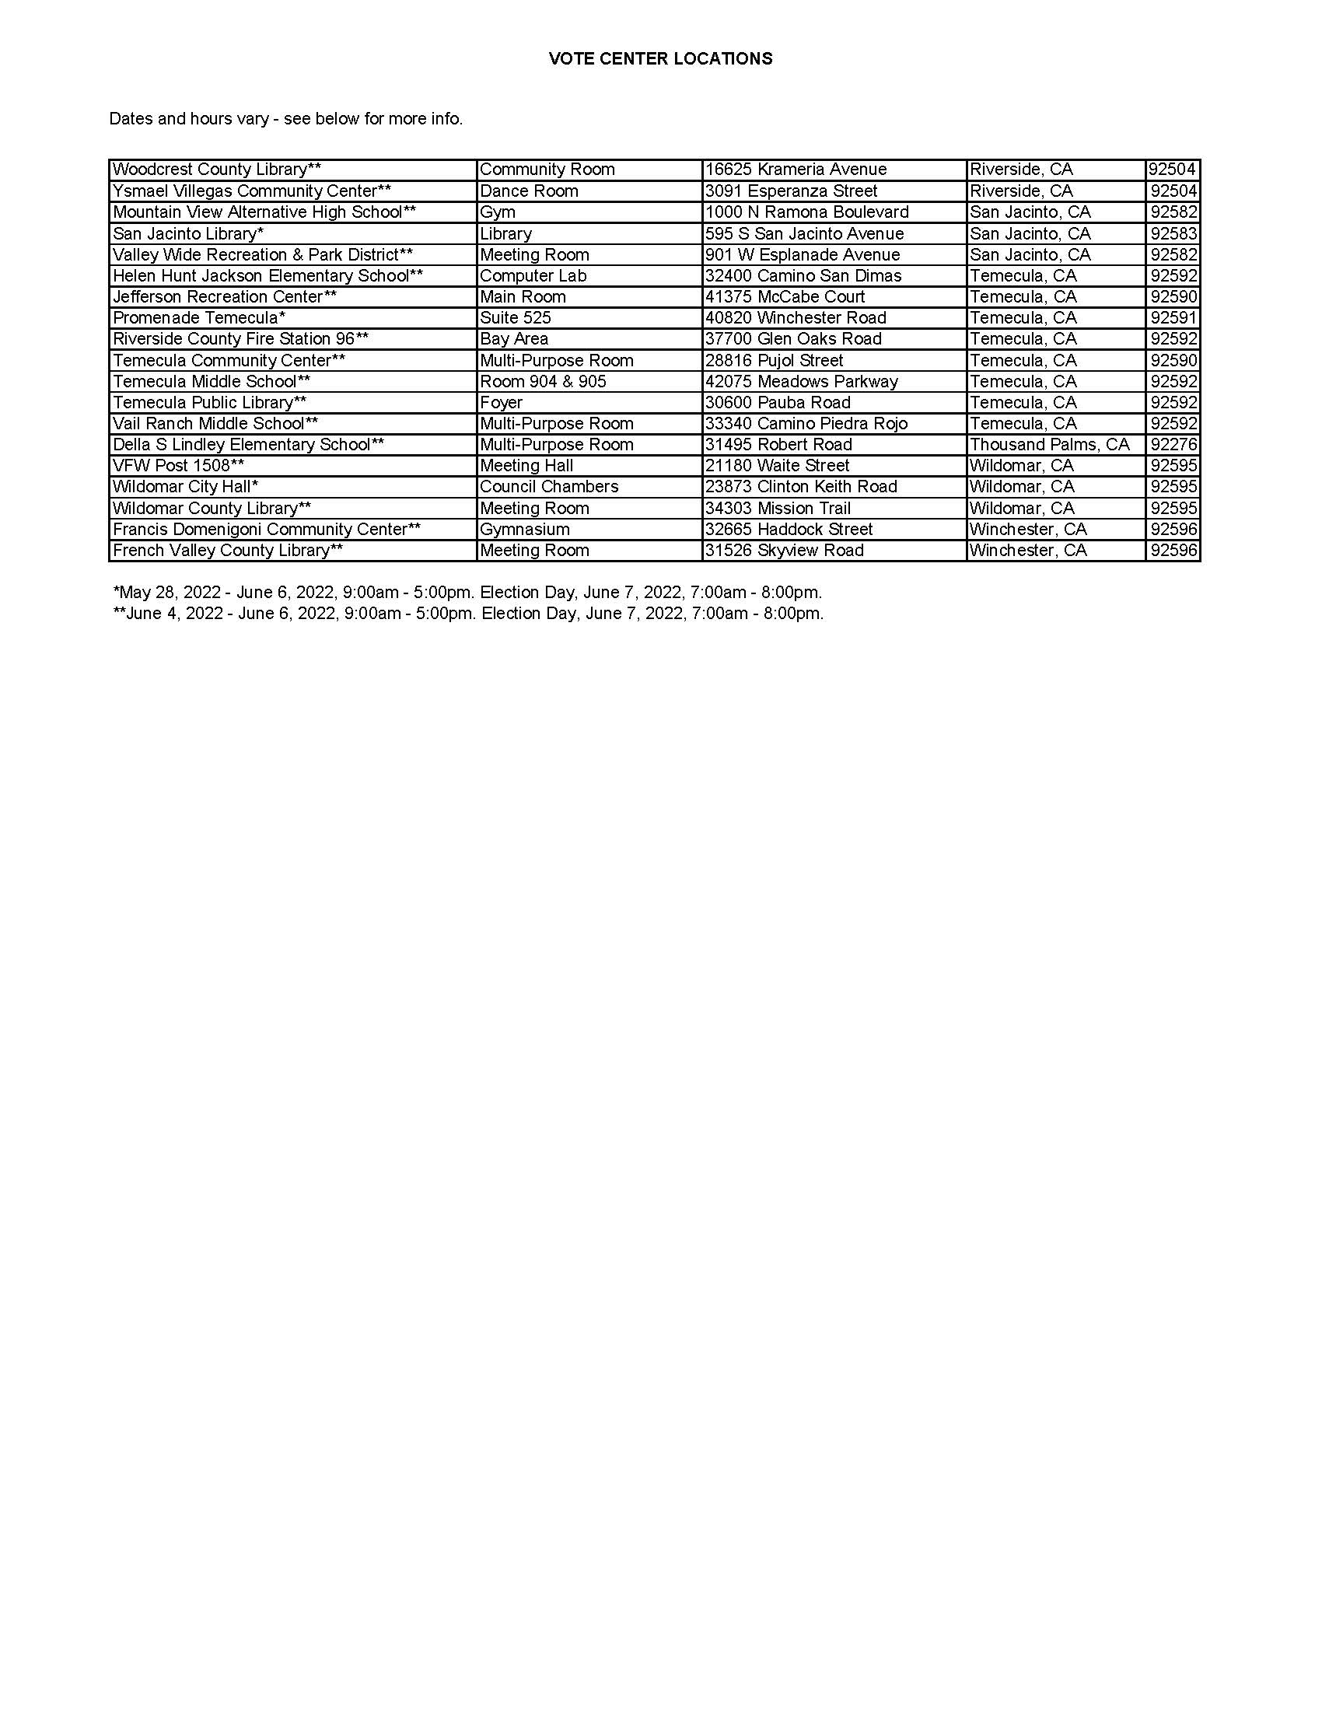
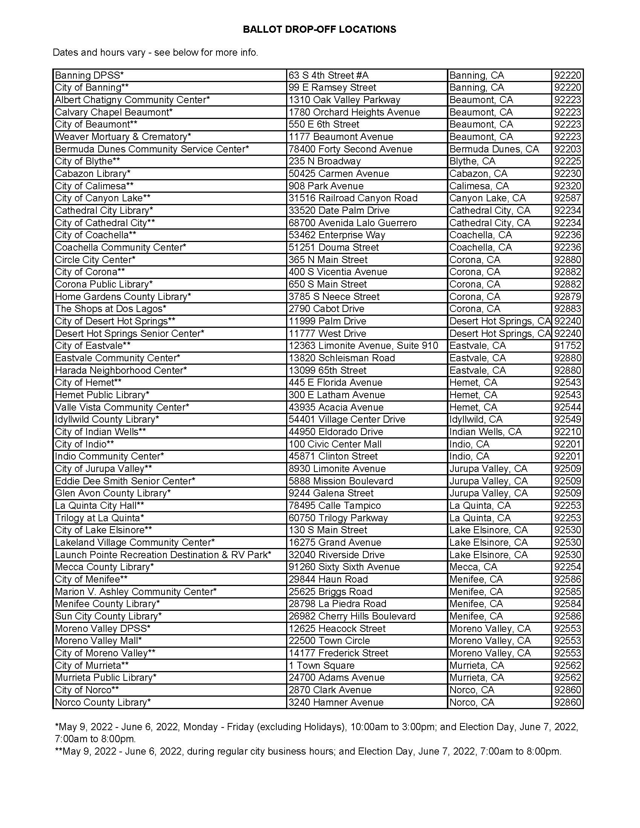
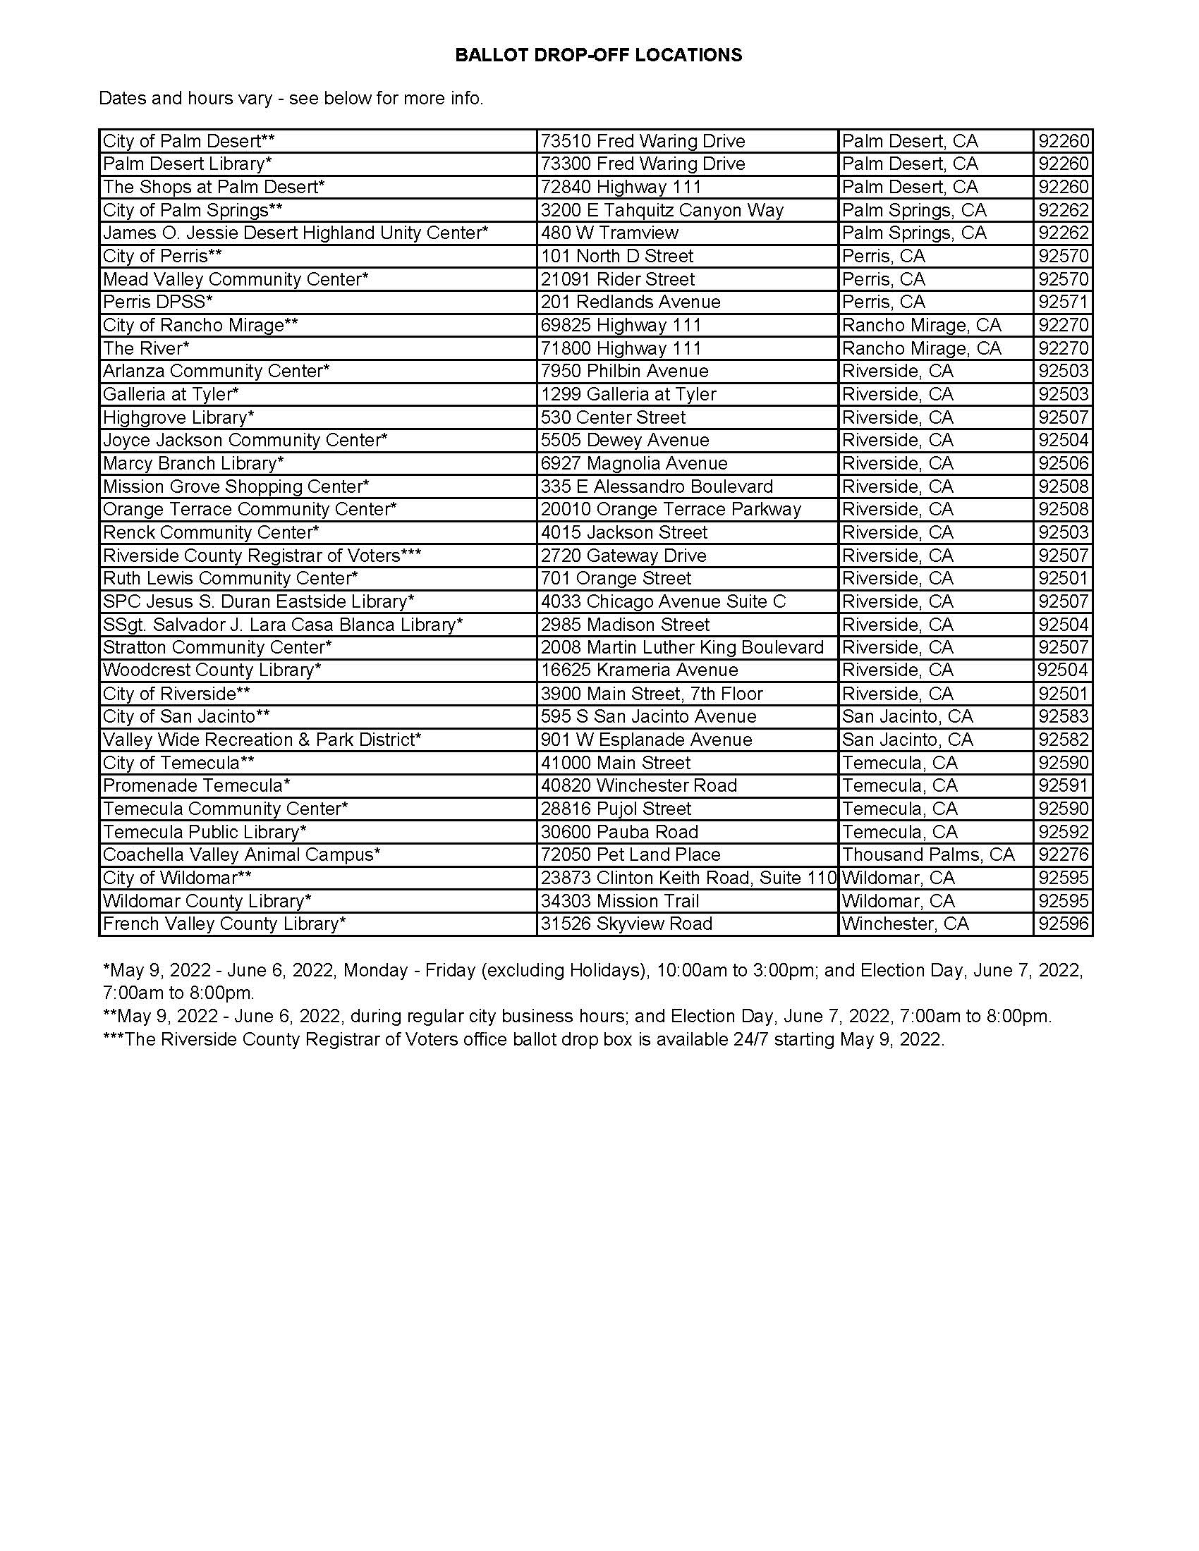
R.O.V.E.R.
The Registrar of Voters’ Registration, Outreach, Voting and Educational Resource, or ROVER, mobile community engagement unit. This vehicle serves as a resource for voter education and a voting venue in case of emergency or disaster impacting Election Day.

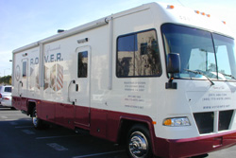

Riverside County Media Outlets
A key component of reaching out to Riverside County citizens alerting them about the county’s final move to the Voters Choice Act is working with our media partners to help promote the work being done at the Registrar of Voters office. Here is a list of local media outlets as provided by the County’s Public Information team.
Eastern Riverside County
Alpha Media
Associated Press
Banning Record Gazette
Desert Newsletter
Desert Review
Desert Sun
Idyllwild Town Crier
Imperial Valley Press/Adelante Valle
InlandEmpire.US
KESQ News Channel 3
KESQ-TV/CBS-Local 2/KDFX-TV/KUNA-TV
KJMB FM 100. 3
KNBC News
KPCC/SoCal Public Radio/LAist
Palo Verde Valley Times/Quartzsite Times
Uken Report
Valley News/Village News/Anza Valley Outlook/Reeder Media
KUNA
Univision Palm Springs
Western Riverside County
Print Media
Associated Press
Black Voice News
Bugle, The - Temecula/Murrieta/Elsinore
City News Service
High County Journal
Idyllwild Town Crier
Inland Living/Riverside Magazines/Sun/Daily Bulletin
Inland News Today/Inland Empire News Radio
InlandEmpire.US
Los Angeles Times
Patch RivCo Editions
Precinct Reporter
Press Enterprise
Record Gazette
Redlands Daily Facts
Riverside County Record
San Bernardino American News
San Jacinto Valley Sentinel
Sentinel Weekly News
Sun
Sun/Inland Valley Daily Bulletin
Valley Business Journal, The
Valley Chronicle, The - Hemet
Valley Messenger, The
Valley News/Village News/Anza Valley Outlook/Reeder Media
Westside Story Newspaper
Yucaipa/Calimesa News Mirror
La Prensa
Television and Radio
ABC7 KABC-TV
CBS2 KCAL9 KNX 1070
Inland News Today/Inland Empire News Radio
KATY 101.3 The Mix
KCAA 1050 AM 106. 5 FM 106. 3 FM
KESQ NEWS CH. 3ABC CBS Local 2 KDFX KUNA
KESQ News Channel 3
KFI Radio
KFRG 92. 9/95. 1
KHTI Hot 103.9
KNBC Channel 4
KNX 1070 Newsradio
KOLA 99.9FM
KPCC/LAist
KSXB 105.7
KTIE 590 AM Newstalk Radio
KTLA Chanel 5
KVCR
KVEA/KWHY Channels 52 and 22

Voter’s Choice Act Criteria Maps
Public Transit Routes

Areas with Low Vote-by-Mail Usage

Population Density

Language Communities

Voters with Disabilities

Low Household Vehicle Ownership

Low-Income Communities

Areas with Eligible Residents Who are Not Yet Registered to Vote

